
Title IX was created in 1972 to end sex discrimination in education. However, Congress and the Dept. of Education realized, even then, that single-sex sports were an important exception to ensure equal opportunity. New “gender identity” policies threaten to set women back decades in progress.

Benefits of Sports Opportunities to Women and Girls  According to the Women’s Sports Foundation, women and girls who play sports:  - Demonstrate higher levels of confidence and self-esteem, more positive body-image, and lower levels of depression  - Achieve better grades in school, and are more likely to graduate  - Are less likely to experience unwanted pregnancy  - Enjoy health benefits, including decreased risk of breast cancer | Differences Between Male and Female Physiology  Most “gender identity” policies do not require any physical or hormonal changes for men to identify as women to compete in female sports.  - World Rugby report found males have significant biological differences from females, including higher muscle mass, larger hearts and lungs, 30%-60% greater strength, and 10-15% greater running speed which increase risk to injury for female athletes  - The fastest women in the world, Olympic finalists, would be easily out-run by high school boys  - Biological differences between males & females were “only slightly reduced” with testosterone suppression.

Polling Shows Americans Support Single-Sex Sports  When asked, “Should boys and men who say they identify as transgender be allowed to complete in girls’ and women’s sports?” two-thirds of American voters said NO. [poll source]  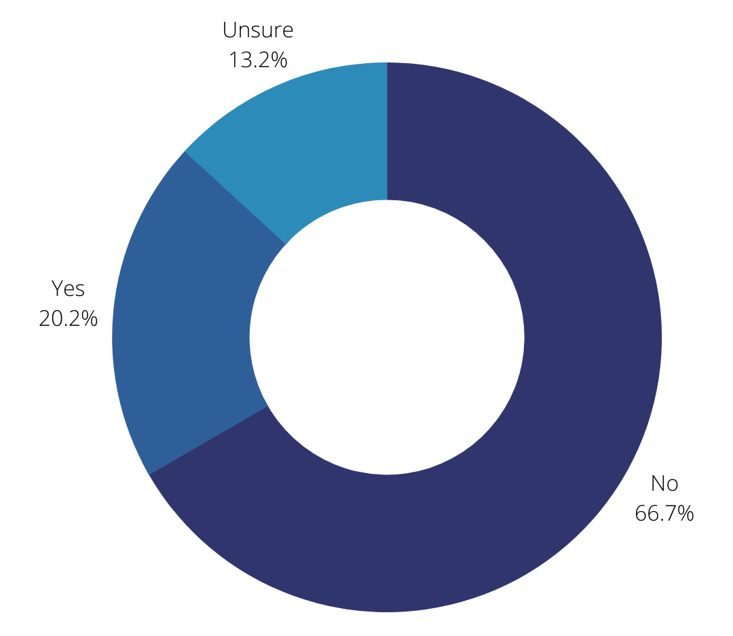 | Examples of Harm to Women and Girls Forced to Compete Against Males  Allowing men and boys to compete in female athletics harms women and girls by reducing opportunities for success, and making competition less safe. These are just a few examples. See here for more.  - Selina Soule and other high school girls in Connecticut were pushed out of qualifying for New England regional track meet spots by two trans-identified males. She lost the chance to be seen by college recruiters and likely lost potential scholarships.  - MMA fighter Fallon Fox, a man who identifies as a woman, fractured a woman’s skull to win a match  - Mary Gregory, a man, took four women’s powerlifting medals in the 2019 “100% Raw Powerlifting Federation” competitions
“Sport can be one of the great drivers of gender equality, by teaching women and girls the values of teamwork, self-reliance and resilience.” - Phumzile Mlambo-Ngcuka, Under-Secretary-General of the United Nations and Executive Director of UN Women (2019)

